

Information Security Fundamentals Project

By

**Leen Almousa 2021268**

**Selen Qarajeh 20210622**

**Qabas Ahmad 20210786**

Supervised by

Dr.Haitham Alani

at

PRINCESS SUMAYA UNIVERSITY FOR TECHNOLOGY

Amman, Jordan

Fall 2023/2024

**Part 1 (Setup your own secured webserver) (5 Points)**

**Objective 1 Set Up a Web Server:**

Using Windows, through installing XAMPP (which includes Apache)

1-Turn on Apache in XAMPP:

Launch XAMPP and start the Apache server.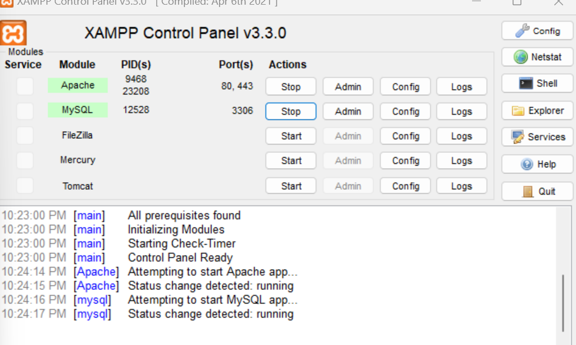

2-Run XAMPP as Administrator:

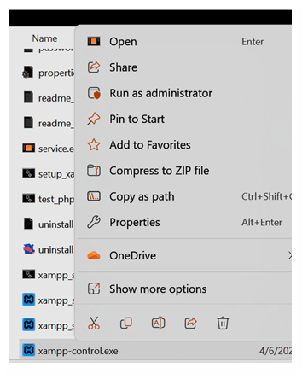Run XAMPP with administrative privileges to ensure proper configuration changes.

3-Open XAMPP Localhost:

Verify the successful start of Apache by opening XAMPP's localhost in a web browser.

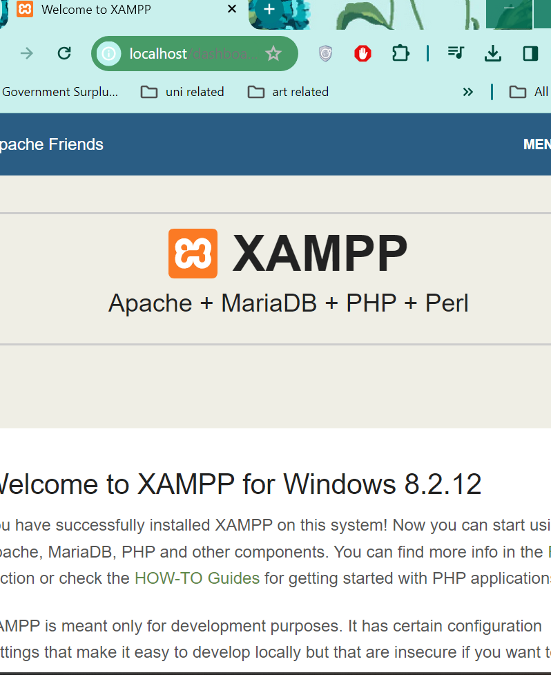

4-Create a Folder in htdocs:

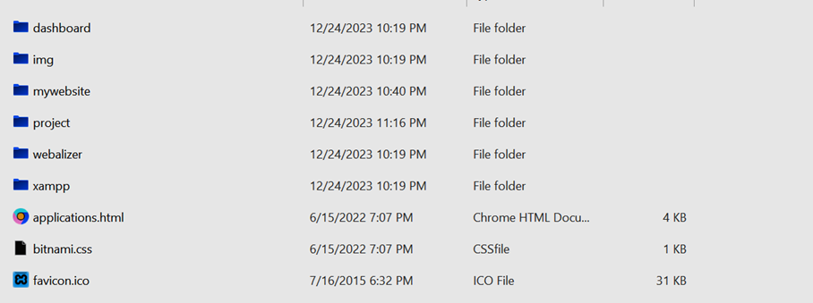Within the XAMPP directory, navigate to the htdocs folder, and create a new folder with the name of your website.

5-Create and Edit Index File:

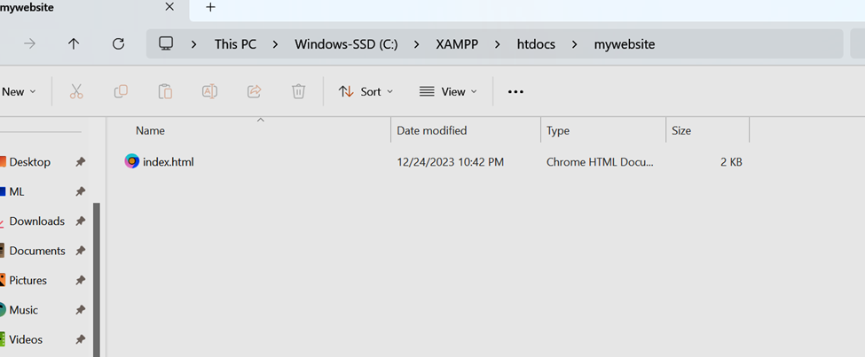Create a text file named "index" and change its extension to .html. Edit the file to add the content of your website.

6-Editing Content:

Using a text editor , edit the content of the website within the index.html file.

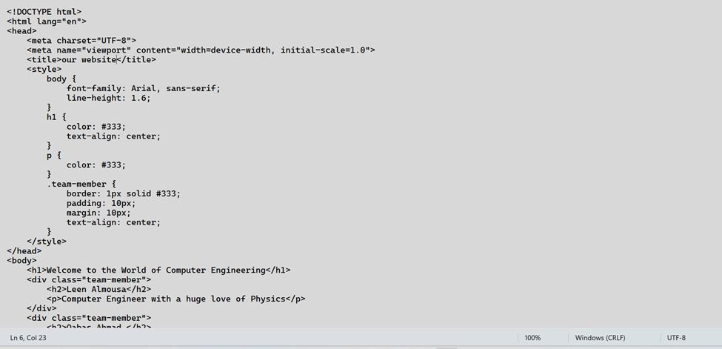

7-Open Website:

Open the website using localhost to ensure everything is working.

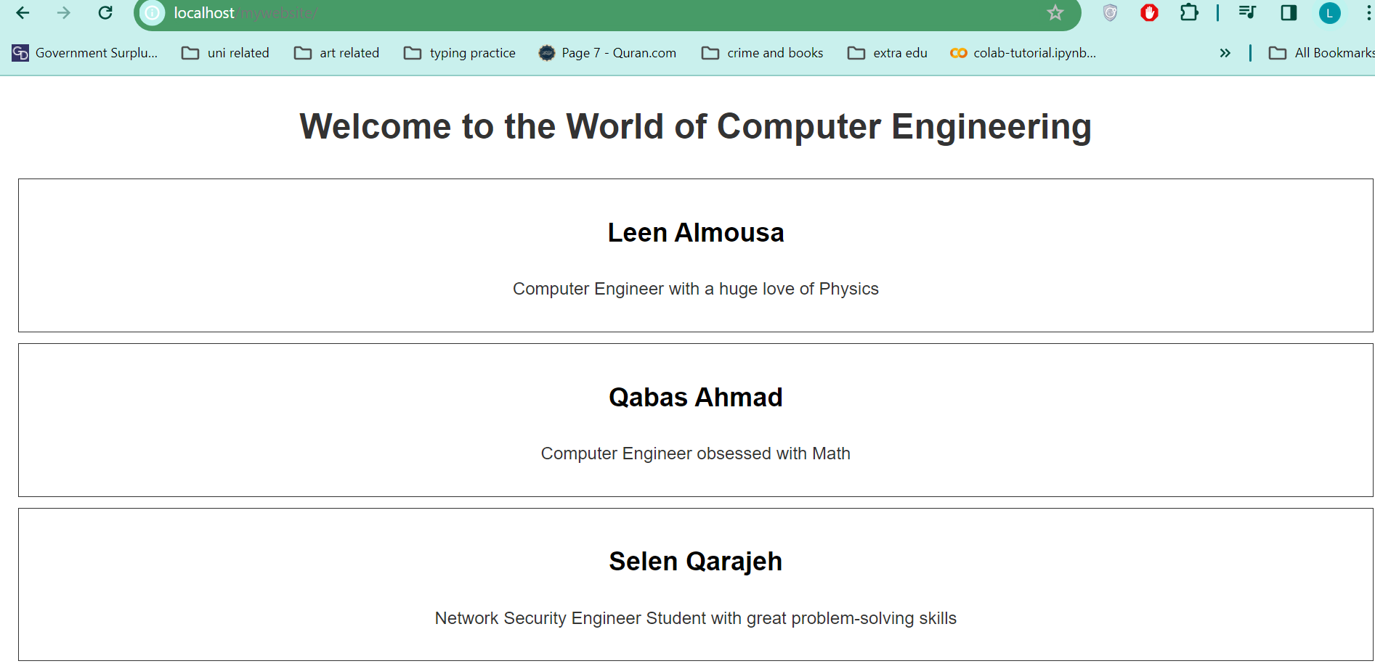

8-Open makecert.bat:

Open the makecert.bat file, typically used for generating SSL certificates.

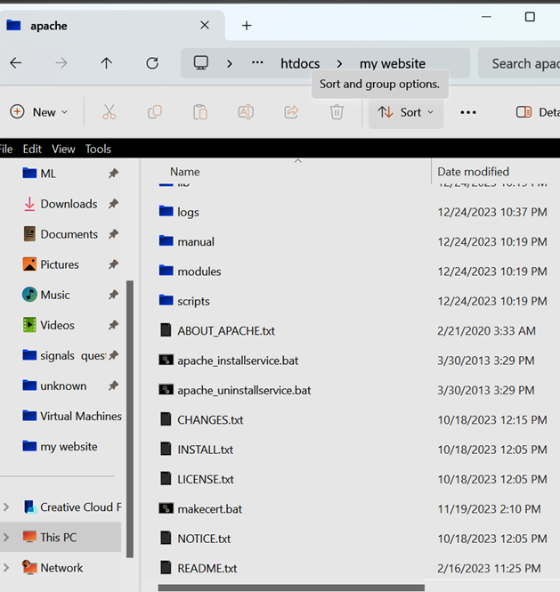

9-Fill in Required Data:

Provide the required data in makecert.bat for creating a self-signed SSL certificate.

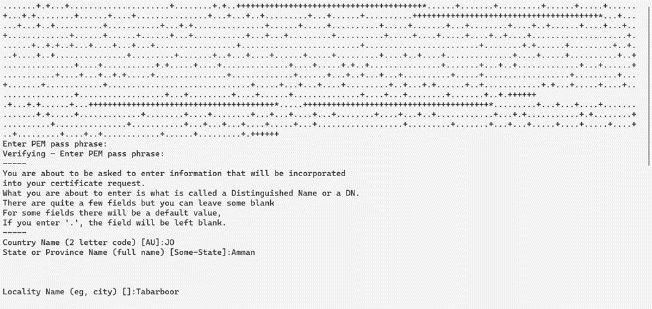

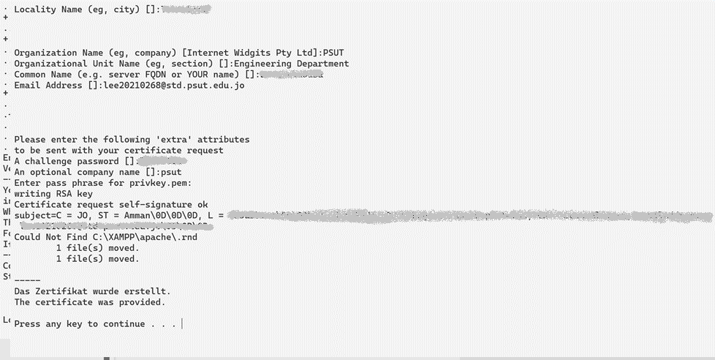

10-Check Certificate:

Verify that the certificate has been generated. Usually, it can be found in C:\XAMPP\apache\conf\ssl.crt.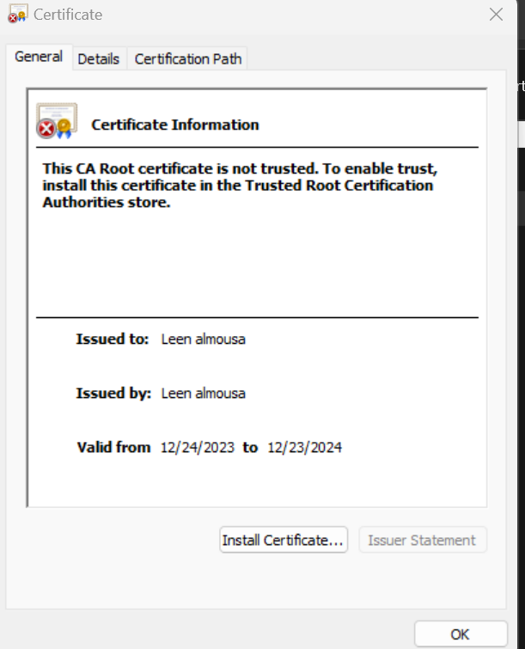

11- Install the certificate :

Install the generated SSL certificate on the local machine.

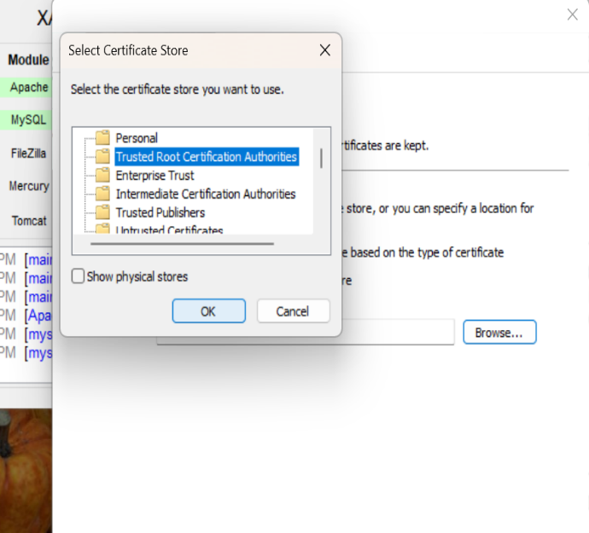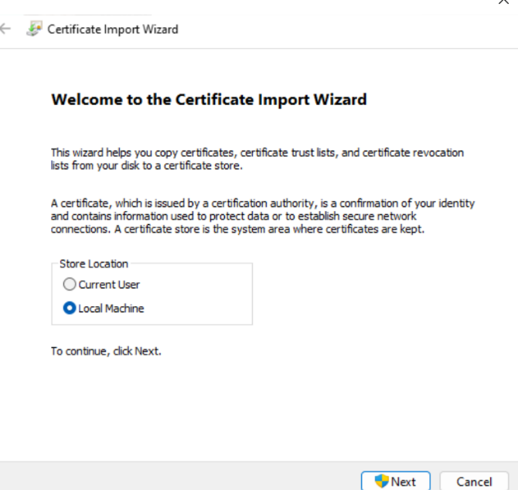

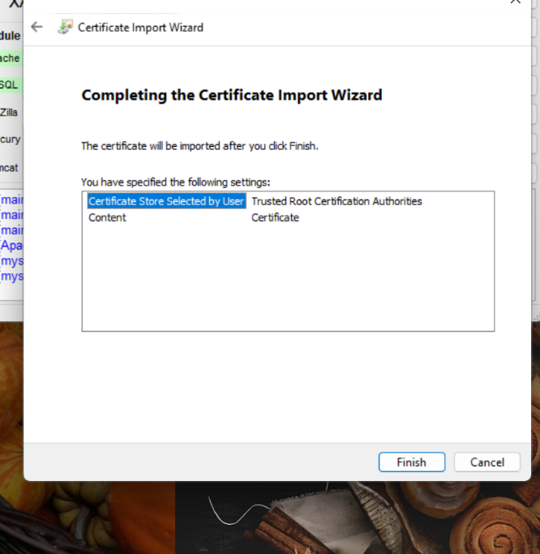

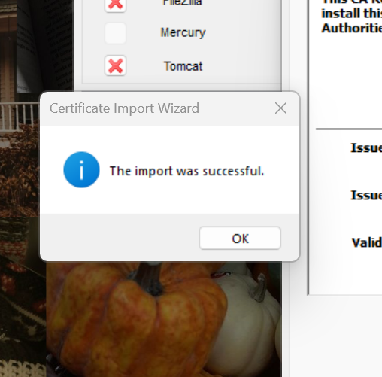

12-Edit http.conf:

Open the httpd.conf file and ensure that both necessary commands related to SSL are not commented.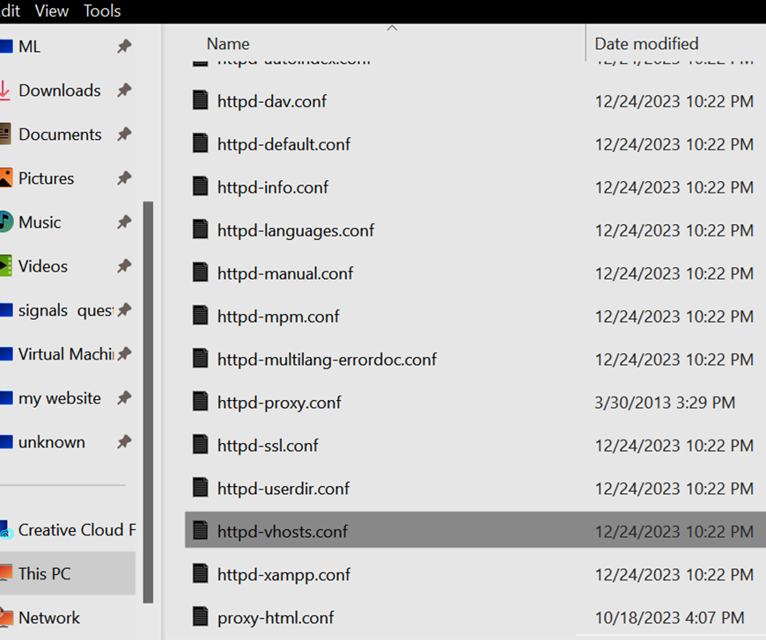

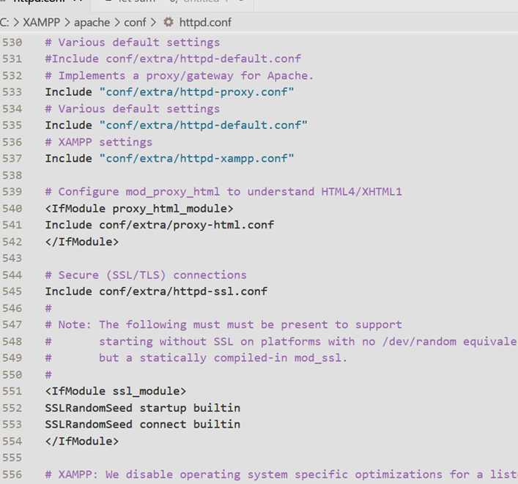

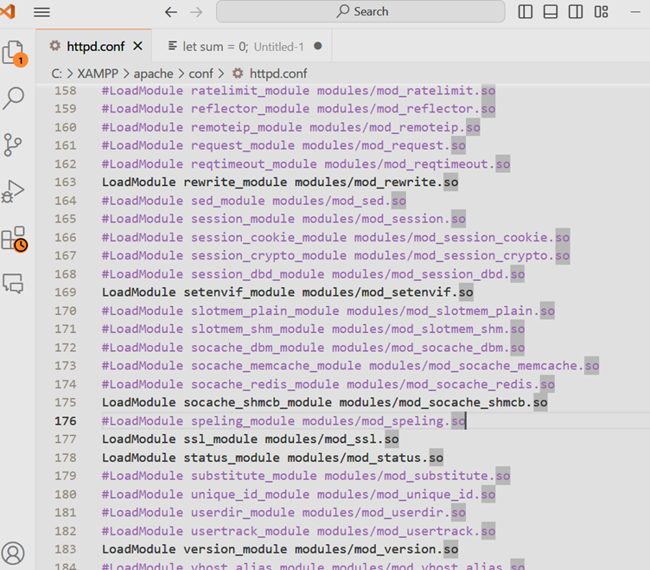

13-Edit httpd-vhosts.conf:

Open "C:\XAMPP\apache\conf\extra\httpd-vhosts.conf" and include configurations for port 8433 (HTTPS) with the generated SSL key and certificate.

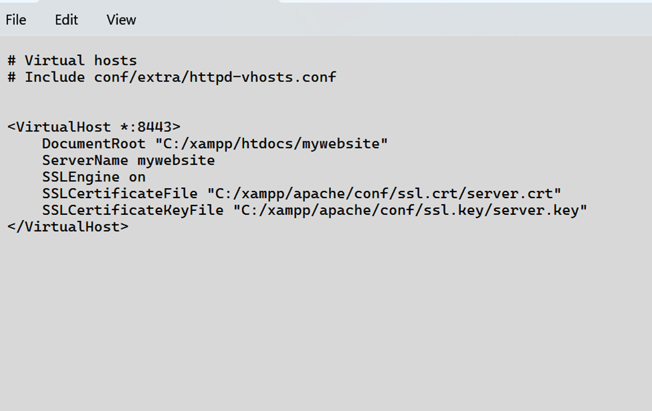

14-Restart Apache: Restart the Apache server to apply the new configurations.

15- Open Website Using HTTPS:

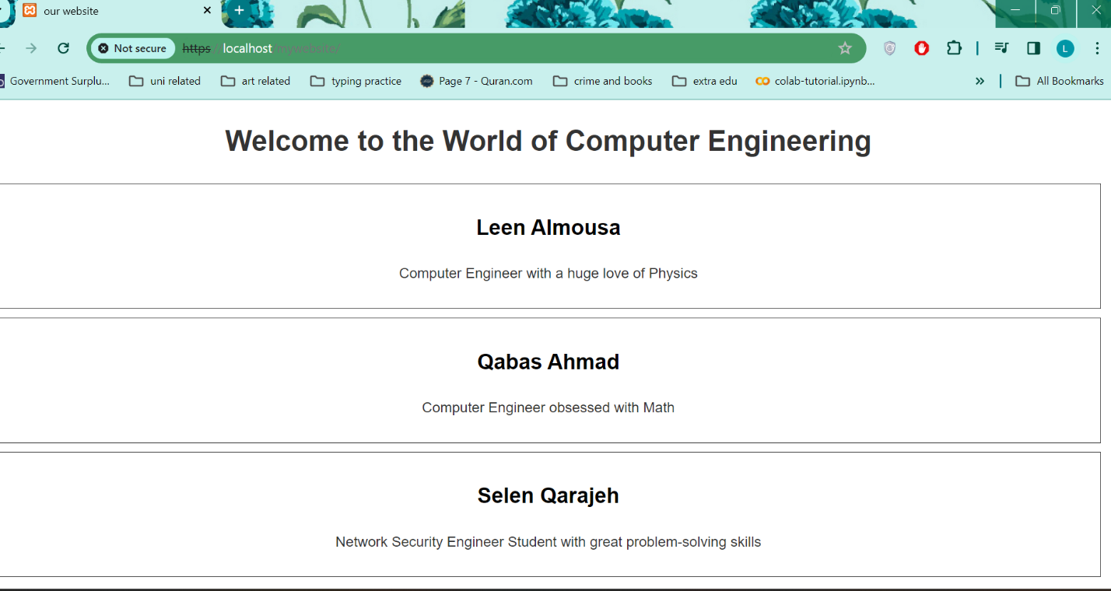Access the website through the secure HTTPS connection.

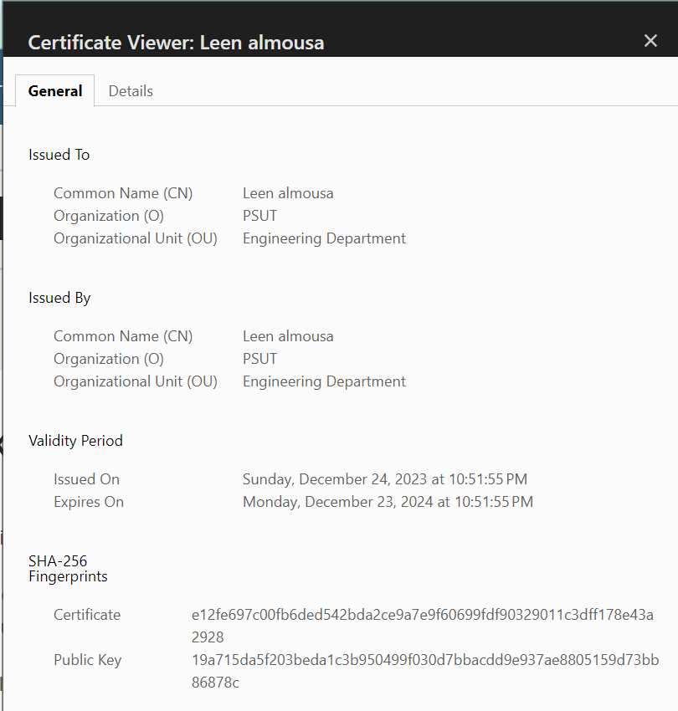

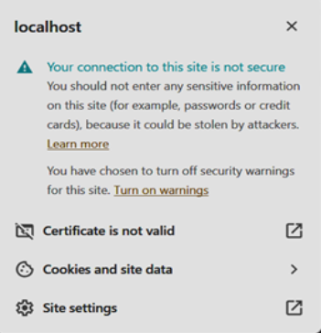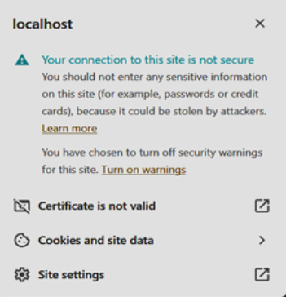

Open Website Using HTTP:

Verify the accessibility of the website through a standard HTTP connection.

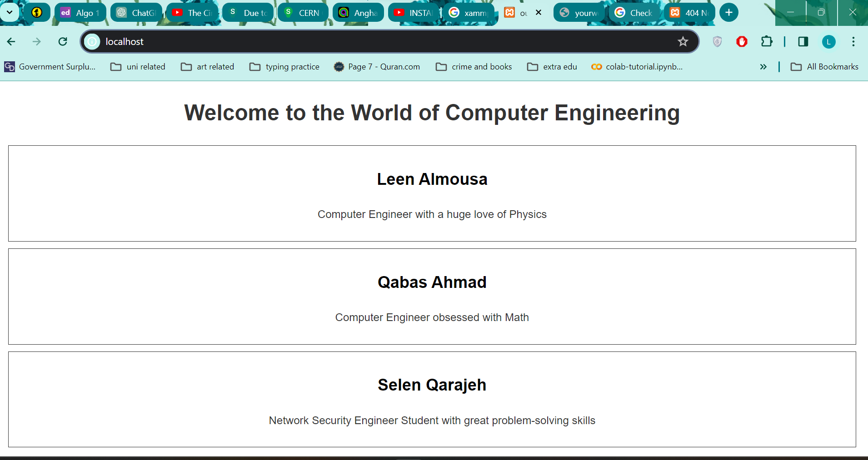

**Part 2 (Man In The Middle Attack) (5 points)**

**Objective 1 - Setup a Controlled Environment:**

We will be using a kali linux machine as the attacker, another kali machine as the client, and windows as the server(host). Below is the Windows host’s IP address.

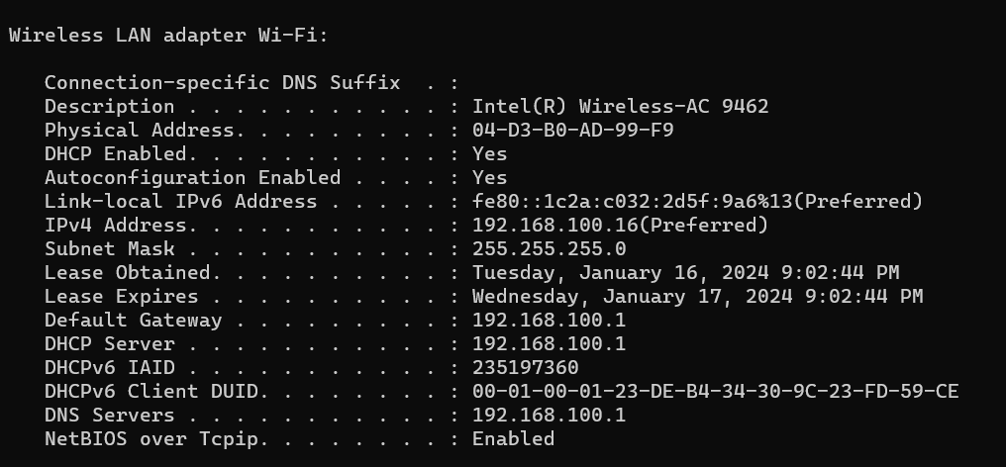

We set up the client (target), and the attacker machine by installing Ettercap tool to preform ARP poisoning.

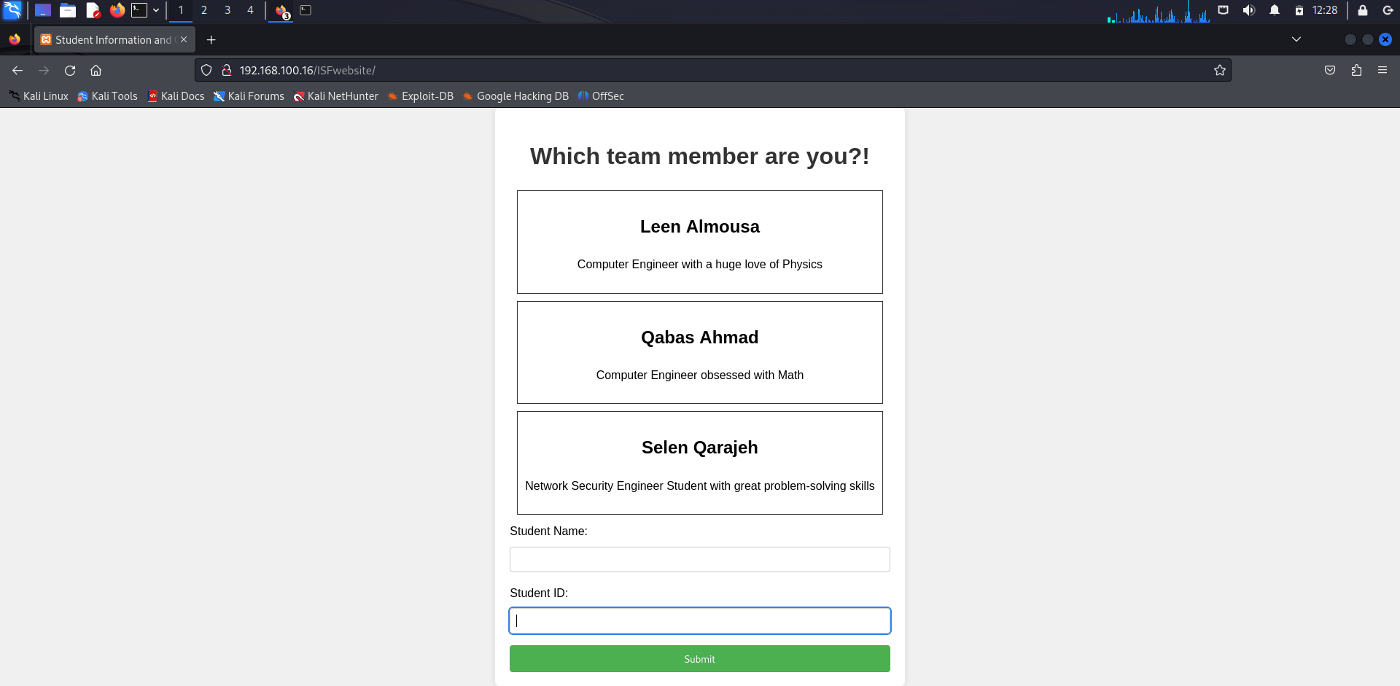

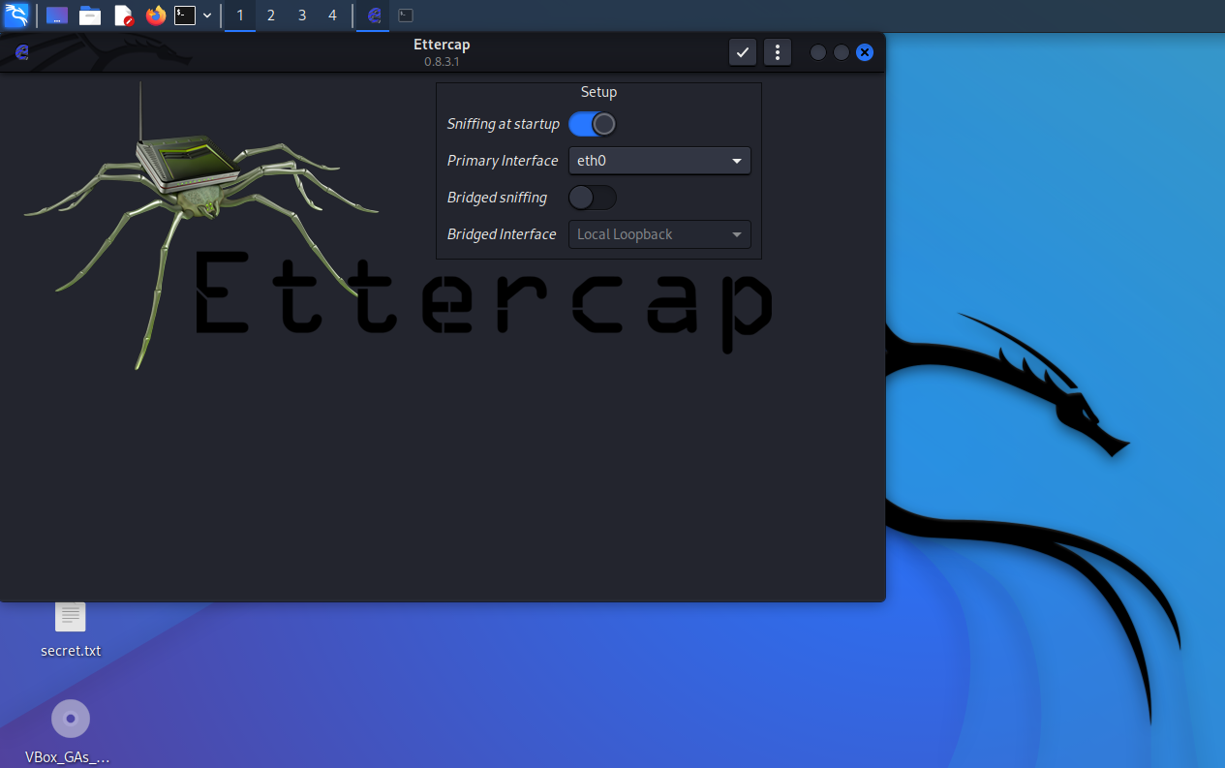

**Objective 2 Configuring the Tools:**

After we start Ettercap, we **scan for hosts** and then display **Hosts List**.

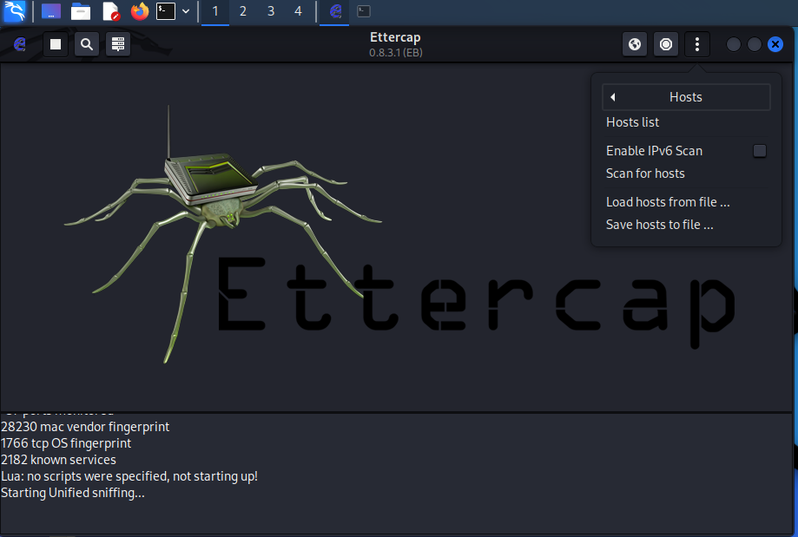

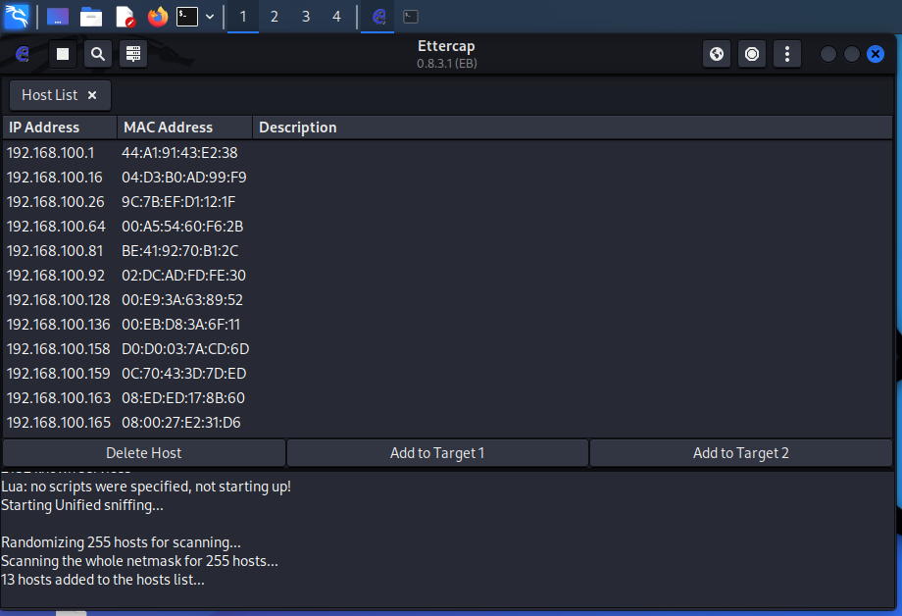

We add the IP address 192.168.100.165 to Target 1, this IP address is that of the client machine. And we add the host’s IP address 192.168.100.16 to Target 2 then we view current targets.

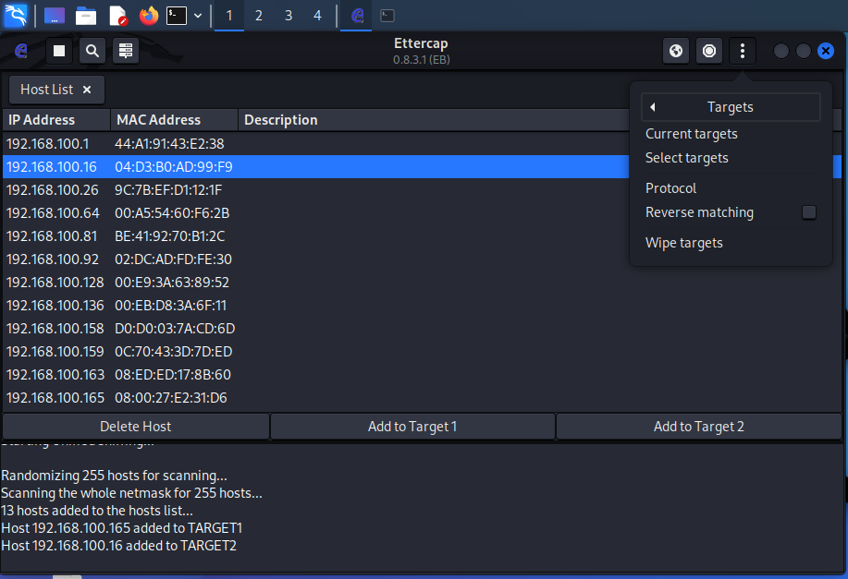

In the man in the middle attack we are doing we choose to do ARP poisoning.

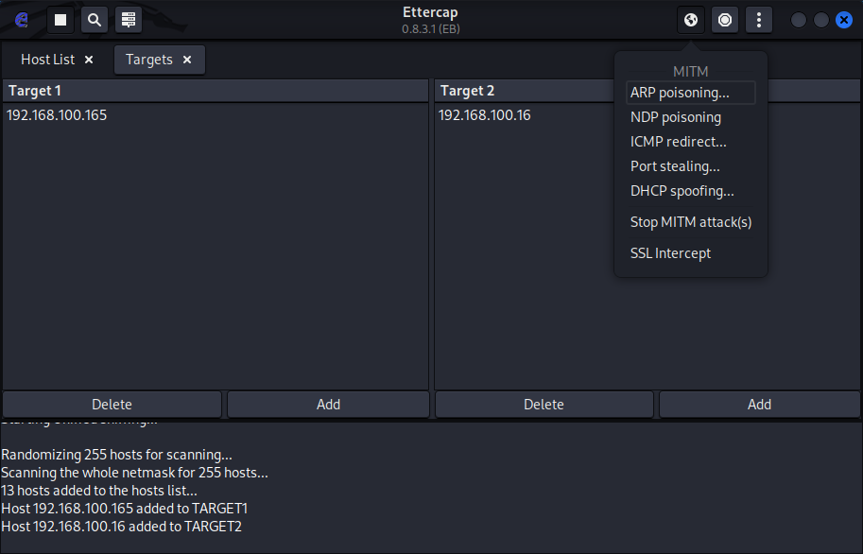

One way to show that ARP cache poisoning was successful is by checking the ARP tables on the computer using the command **arp -a**. We can see that the last two distinct IP addresses, that of the client and the attacker, map to the same MAC address which is that of the attacker.

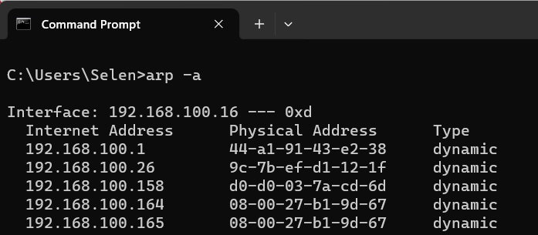

ARP cache poisoning is successful!!

**Objective 3 Sniffing and Capturing Data:**

We should now be able to sniff the network and receive the packets sent from the server to the client. Acting as the victim (the targeted client machine), we submit data in the text boxes on the website.

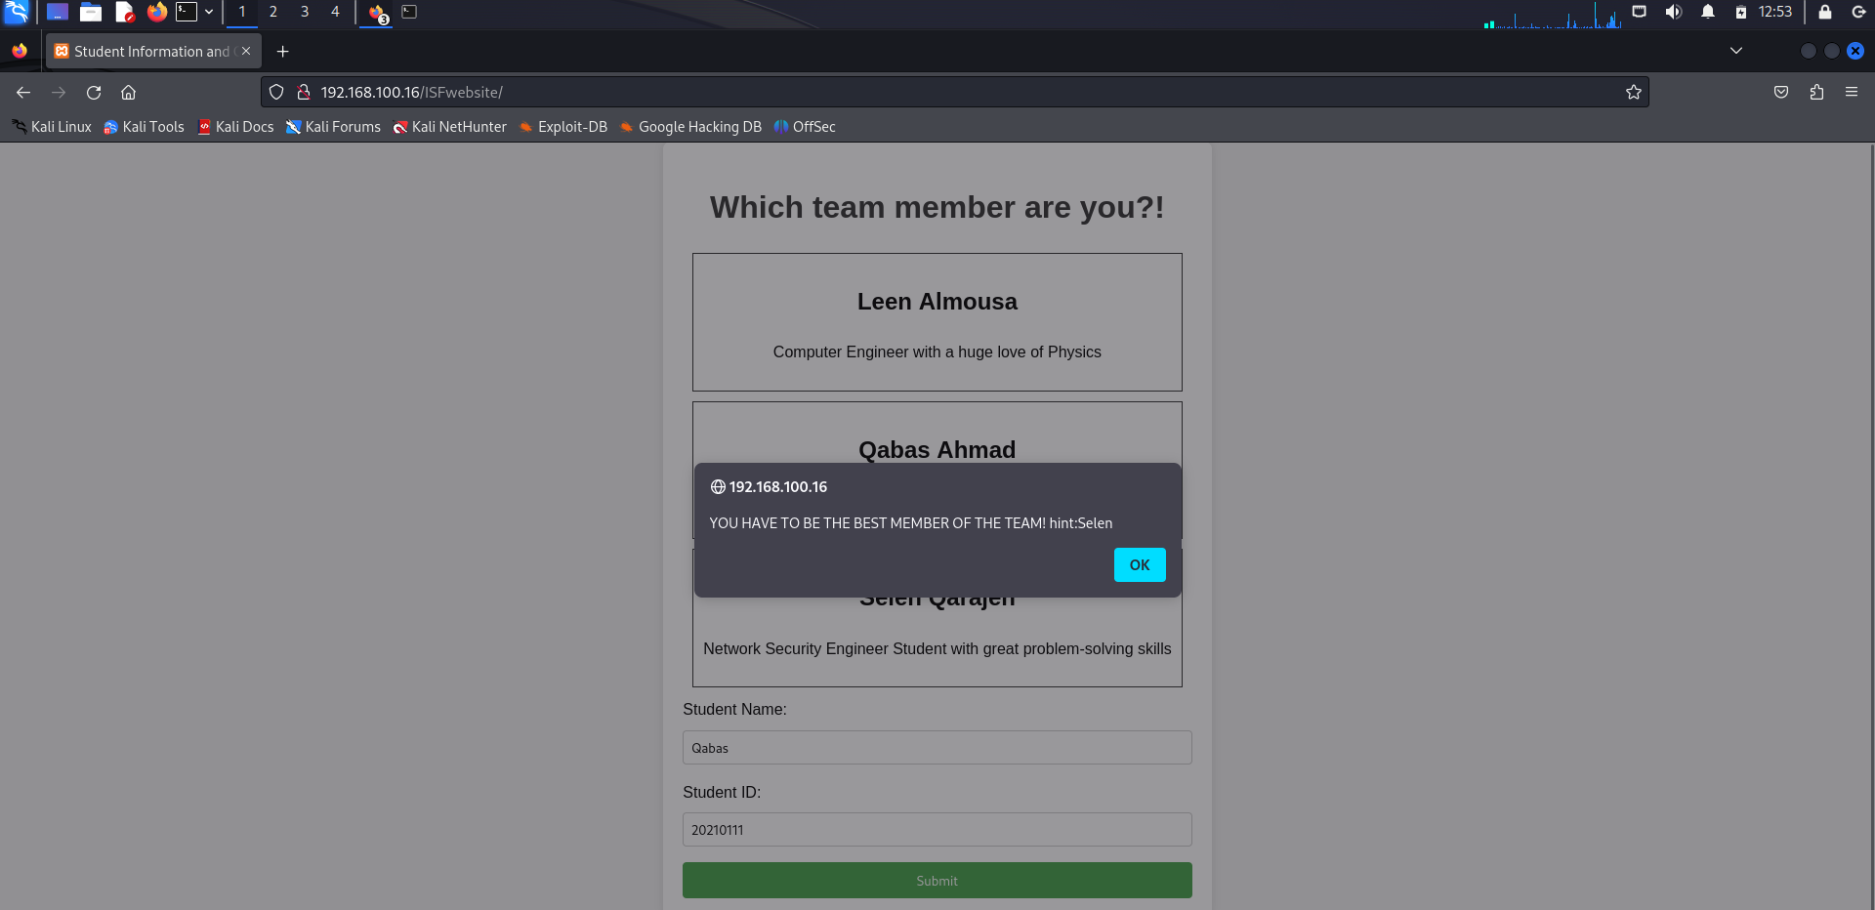

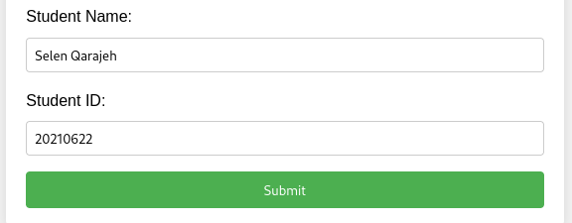

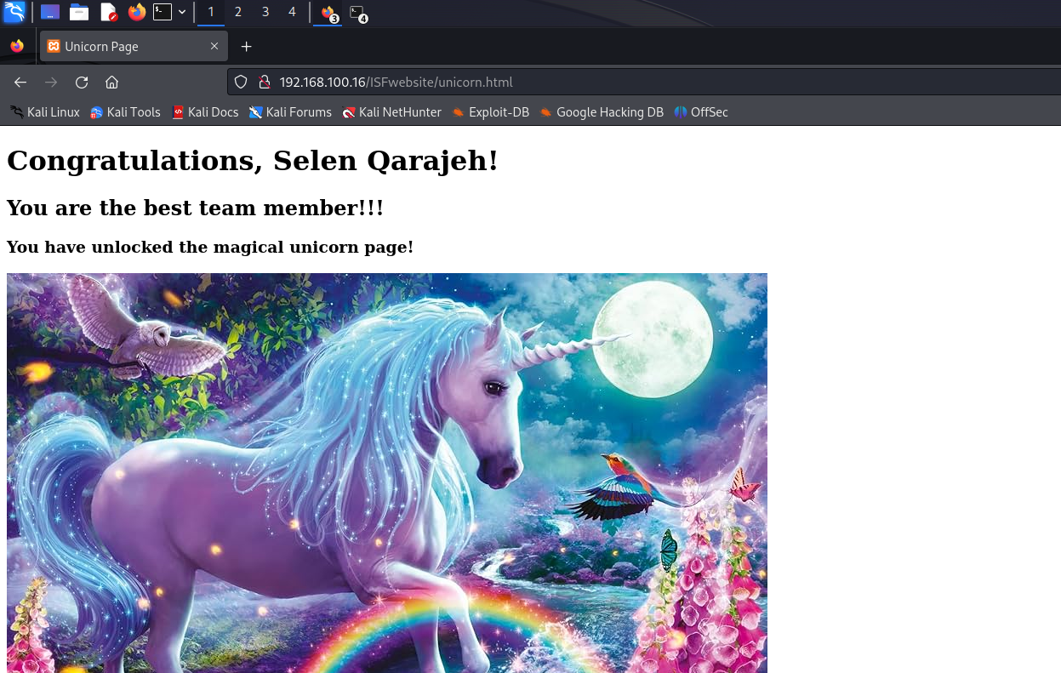

We now use Wireshark from the attacker machine to capture traffic.

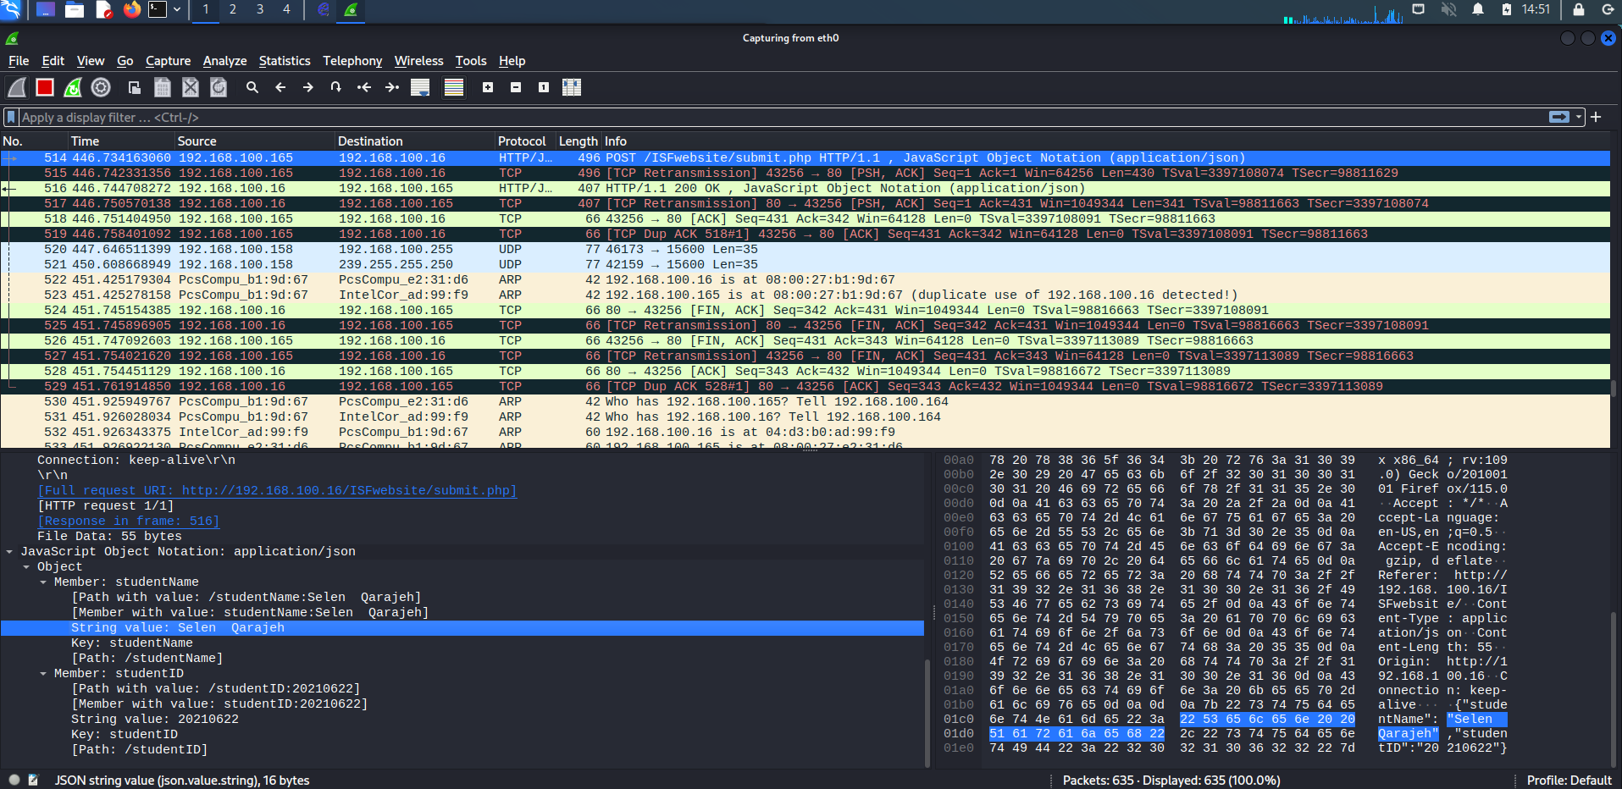

Plain text Credentials captured!

The unsecure traffic I can sniff is that of HTTP. Moreover, DNS queries are not encrypted and can lead to attacks such as DNS spoofing. (if we had a domain name for our server)

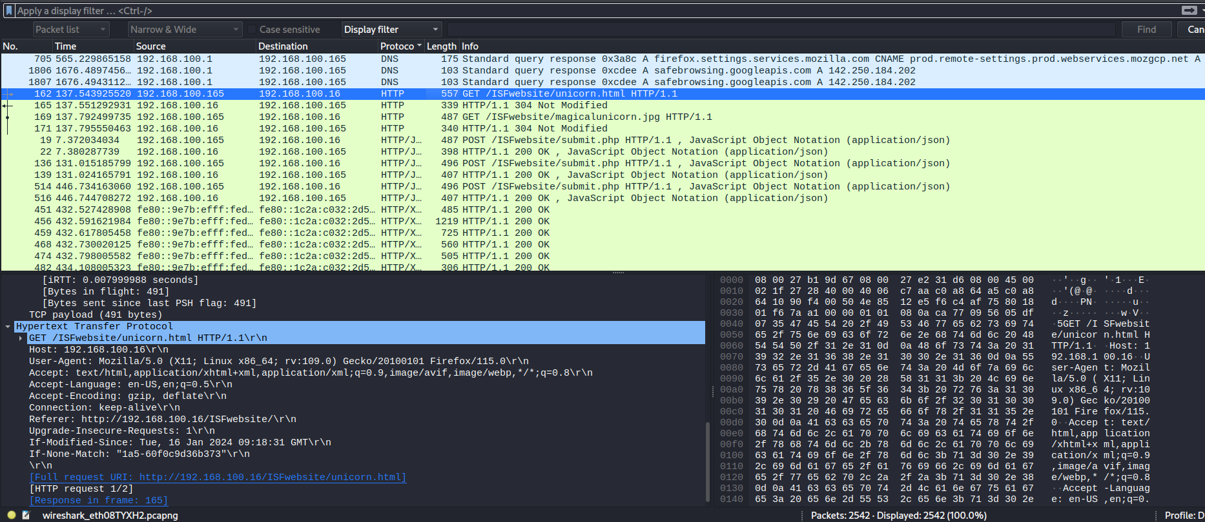

**Objective 4 Use Filters in Ettercap for MITM**

Filters in Ettercap are used to modify, redirect, or analyze specific packets in real-time as they traverse the network. Ettercap has some example filters in its directory that one can use after compiling to ‘*.ef’* . We chose a filter that kills the connection by dropping the packets. Below is the code after adjusting the IP addresses.

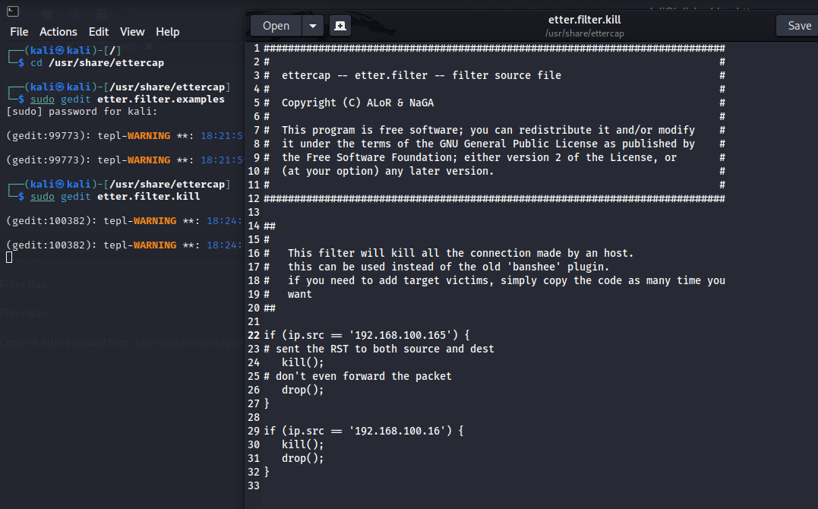

We compiled the text file to *‘.ef’*

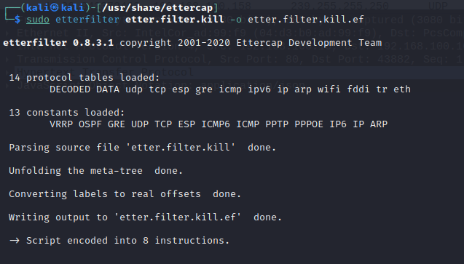

Then we applied the filter, applying the filter could be done through the terminal or from the graphical interface.

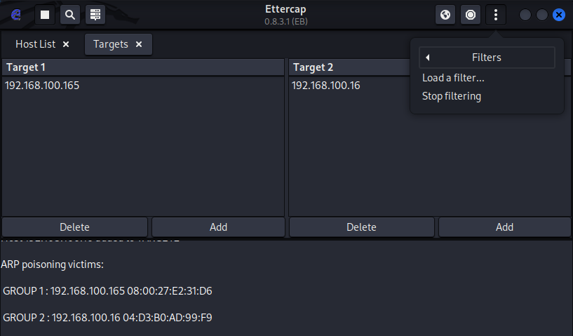

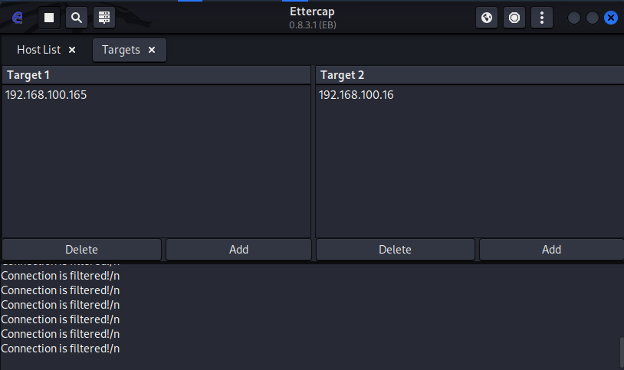

If we return back to the victim machine, we can see that the connection is lost and the attack is successful !

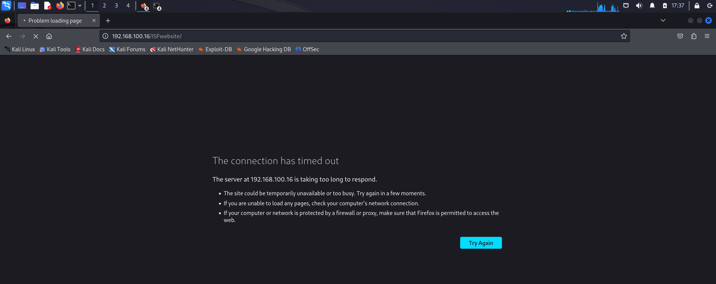

**Part 3 (Password Cracking)**

**Objective 1 SSH Dictionary Attack**

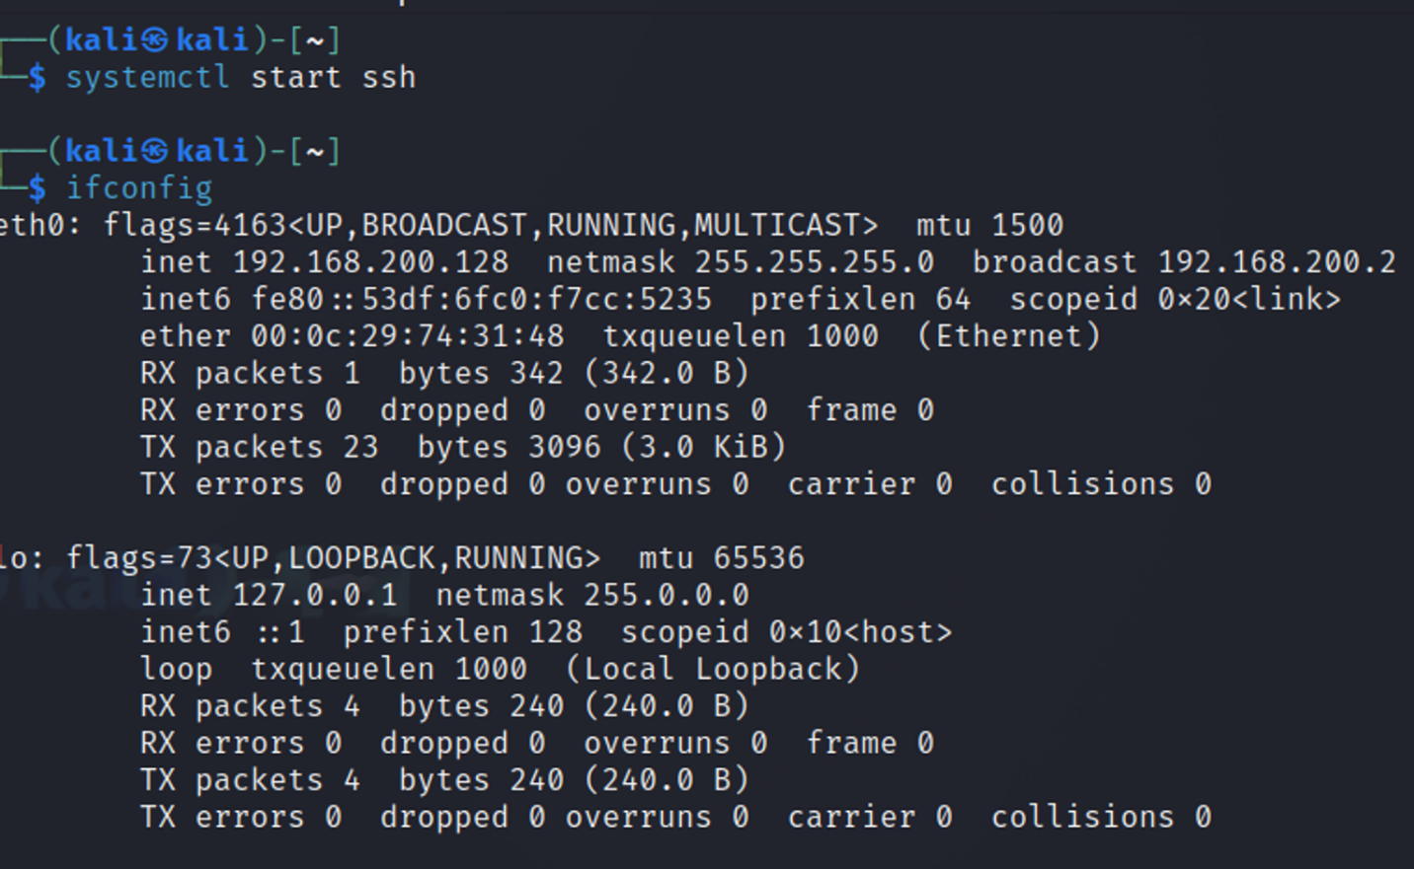Setting up an SSH server on the victim machine and getting the IP address of the victim machine.

Creating a password list on the attacker machine and reading it.

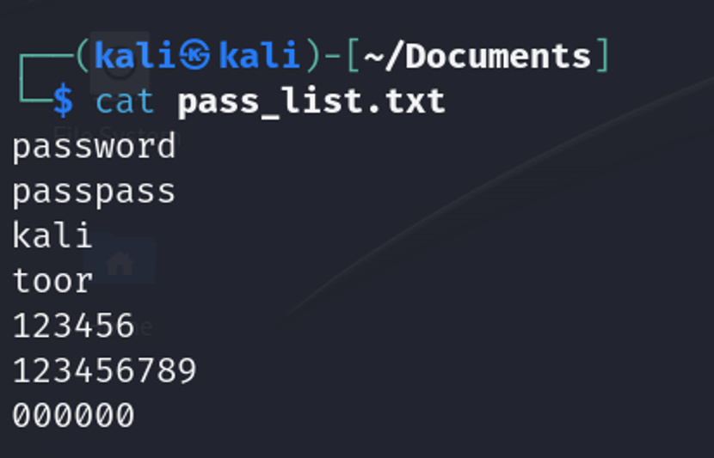

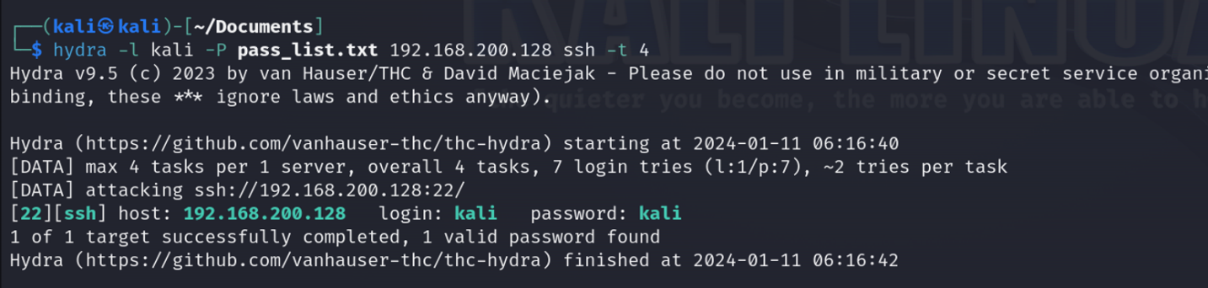Using hydra as a tool to perform SSH dictionary attack on the victim machine.

**Objective 2 Firewall Setup**

We need to detect full and half open scans by sending SYN packets using

sudo iptables -A INPUT -p tcp --syn -m limit --limit 1/s --limit-burst 3 -j LOG --log-prefix "SYN Flood Detection: "

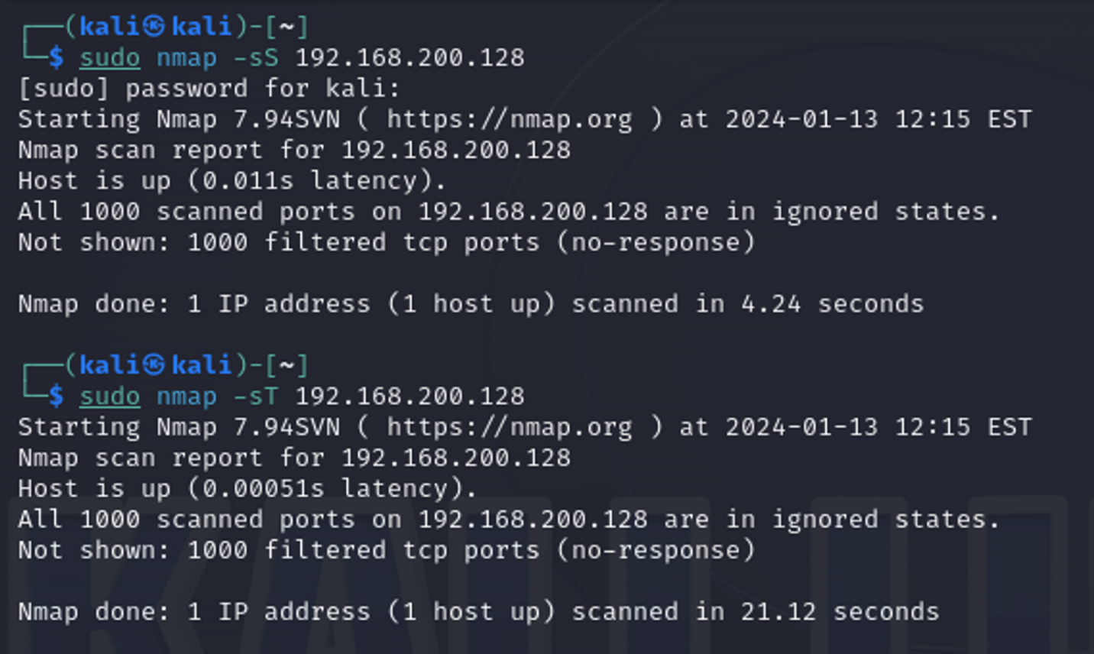Testing:

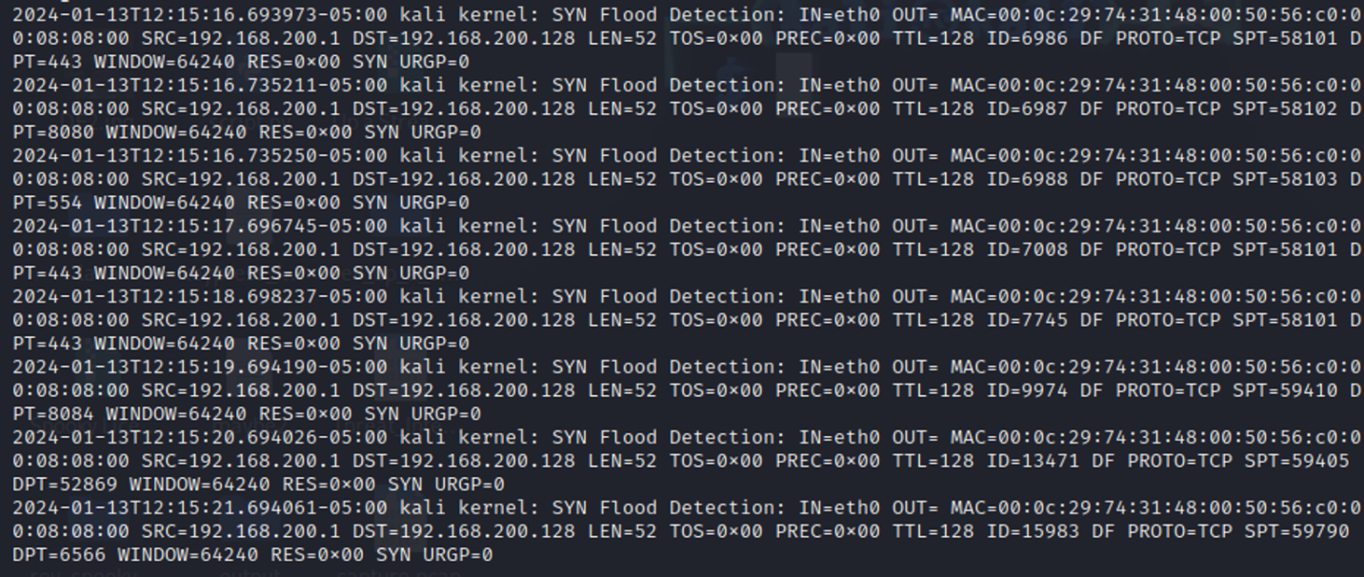

Then we want to detect dictionary attacks on SSH

sudo iptables -A INPUT -p tcp --dport 22 -m recent --name sshattack --set

sudo iptables -A INPUT -p tcp --dport 22 -m recent --name sshattack --update --seconds 60 --hitcount 3 -j LOG --log-prefix "SSH Dictionary Attack Detection: "

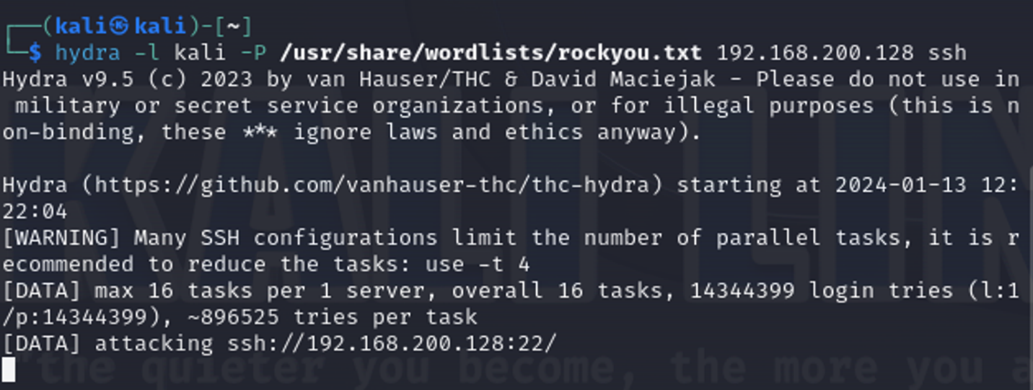Testing:

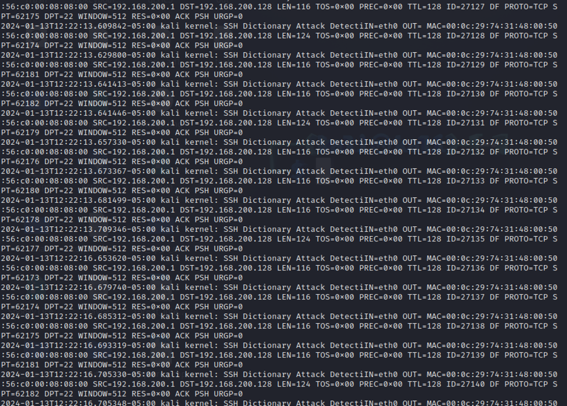

**Objective 3 Hashing Cracking**

Displaying the content of the ‘/etc/shadow’ file using cat commad

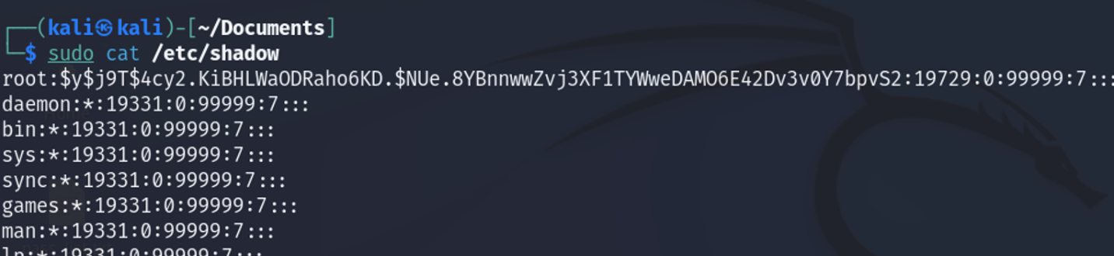sudo cat /etc/shadow

Create a text file (named kali.txt here) and the we add the hash to this text file

kali:$1$zqgDCuOM$NHdjWjBbVDBscYdjijq/A.:19733:0:99999:7:::

where the username is kali and the encryption of the password hash is $1$zqgDCuOM$NHdjWjBbVDBscYdjijq/A.

Cracking the has in order to retrieve the password using john the ripper as the tool.

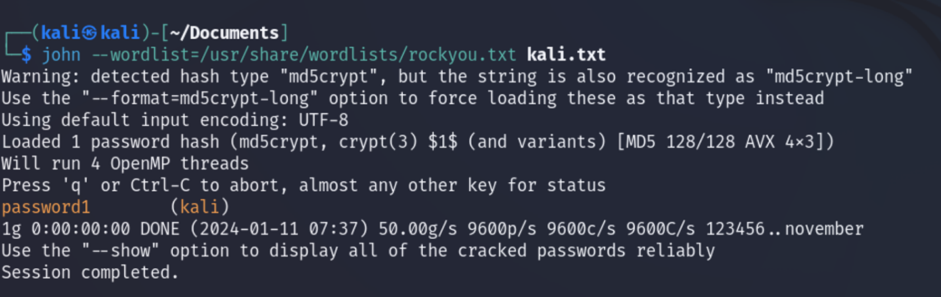$ john --wordlist=/usr/share/wordlists/rockyou.txt kali.txt

And the password was correctly retrieved as “kali”.